10th August 2016

YOKOHAMA tops UK´s EVO magazine’s wet tyre tests

YOKOHAMA’s ADVAN Sport V105 tyre has once again demonstrated its performance credentials, sealing ‘an overall victory across the wet handling tests’ in EVO magazine’s 2016 ultra-high performance tyre test, published today.

The EVO test, which was carried out at a German tyre manufacturer’s proving ground in Texas, used a 247bhp Ford Focus ST. For the first time ever, EVO magazine decided to select a 19” tyre for its tyre test, opting for a 235/35R19 fitment.

The comprehensive review, which evaluated nine leading tyre brands against each other in a series of 11 tests, ranked the YOKOHAMA tyre joint second overall, praising it in particular for its wet weather performance, but also noting it delivered ‘strong performances across the board’ showing what a ‘good all-rounder it is.’

“YOKOHAMA tyres are becoming increasingly popular with both performance enthusiasts and car manufacturers alike,” comments David Seward, Managing Director Yokohama HPT Ltd. “This latest test result and words of praise from EVO magazine underline some of the reasons for the growing popularity. Winning the wet test outright is incredibly pleasing and a great reflection of the hard work of our global technical and development teams.

“In the UK, we experience a significant amount of time, driving around on wet roads. So, as the EVO test shows, if you want to maximise your car’s performance and grip in these potentially treacherous conditions, fitting YOKOHAMA tyres makes a great deal of sense.”

Thanks to its growing reputation and performance credentials, YOKOHAMA tyres are fitted as original equipment by a growing number of vehicle manufacturers including Porsche, Mercedes-Benz and Audi.

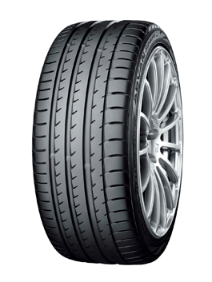 | YOKOHAMA’s ADVAN Sport V105 tyre has won EVO magazine’s 2016 wet tyre test
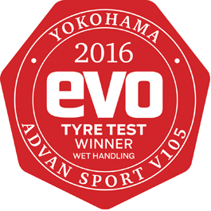 | EVO magazine tested nine leading tyre brands in its annual tyre test

